PJM/IA PROGRAM VERSION 1.0

  - User Manual

Indice

Introdução 2
Requisitos técnicos 4
Módulo de Funcionamento 5
Instalação 9
Modo de Utilização 11

Introduction

This project serves as a support tool for criminal investigations, assisting investigators in the interrogation of witnesses and suspects.
Developed as a modular solution, the PJM/IA program is an innovative system capable of categorizing human emotions through three distinct approaches:

- FER (Facial Emotion Recognition) – Identifies emotions through facial expressions.
- SER (Speech Emotion Recognition) – Analyses vocal tone to detect emotional states.
- Sentiment Analysis – Classifies the sentiment expressed in spoken words.

Beyond being a powerful tool for enhancing interrogations, PJM/IA fully automates the administrative process associated with investigations. The system extracts subject data directly from official records or national identification cards, enabling the automatic completion of standard reports used by the Military Judiciary Police (PJM).

Additionally, leveraging Natural Language Processing (NLP) techniques, the program transcribes entire interrogations from audio to text, providing investigators with instant access to full transcripts.

As a final output, the investigator receives:
- Official PJM reports, automatically populated with relevant data.
- A complementary report detailing emotion analysis throughout the interrogation, recording emotional fluctuations every 10 seconds.
- A video overlay combining insights from all three emotional analysis methods (FER, SER, and sentiment analysis).
This tool represents a significant advancement in criminal investigation, improving efficiency, accuracy, and analytical support during interrogations.

Technical Requirements
Machine Requirements:
Requirement | Minimum | Preferred
Camera | USB-connected camera
Microphone | USB-connected microphone
RAM | 8 gb | 16 gb
Disk Space | 5gb
Operating System | Windows XP | Windows 10 or later
Supported Video Formats | *.mp4;*.avi;*.mov
Supported Audio Formats | *.mp3;*.wav;*.ogg"
Interview Requirements
- The video or live stream should include a maximum of three people.
- For optimal facial feature capture, the interviewee should be centred on the screen and positioned at an appropriate distance, occupying at least one-third of the image.
- The background of the recording should be as neutral and simple as possible, avoiding posters, photographs, or any visual elements that could be mistakenly identified by the program as faces.

Operating Module
The program starts with an authentication window, requiring a username and password. For testing purposes, the credentials are:
Username – "kl3z"
Password – "12345"
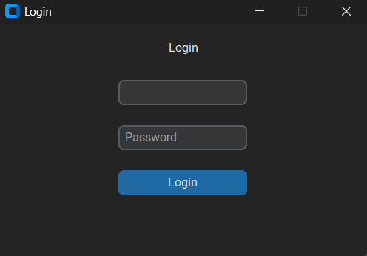
The main window is divided into four distinct sections, each serving a specific function in presenting processed information:
- Top-left section: Displays the interrogated individual's data.
- Bottom-left section: Presents a graphical representation of Facial Emotion Recognition (FER), showing the count of detected emotions.
- Bottom-right section: Displays the Speech Emotion Recognition (SER) graph, tracking the frequency of identified emotions.
- Top-right section: Functions as a control panel, allowing document selection and the input of interview-related information.
This structured layout ensures an intuitive and efficient workflow for investigators.
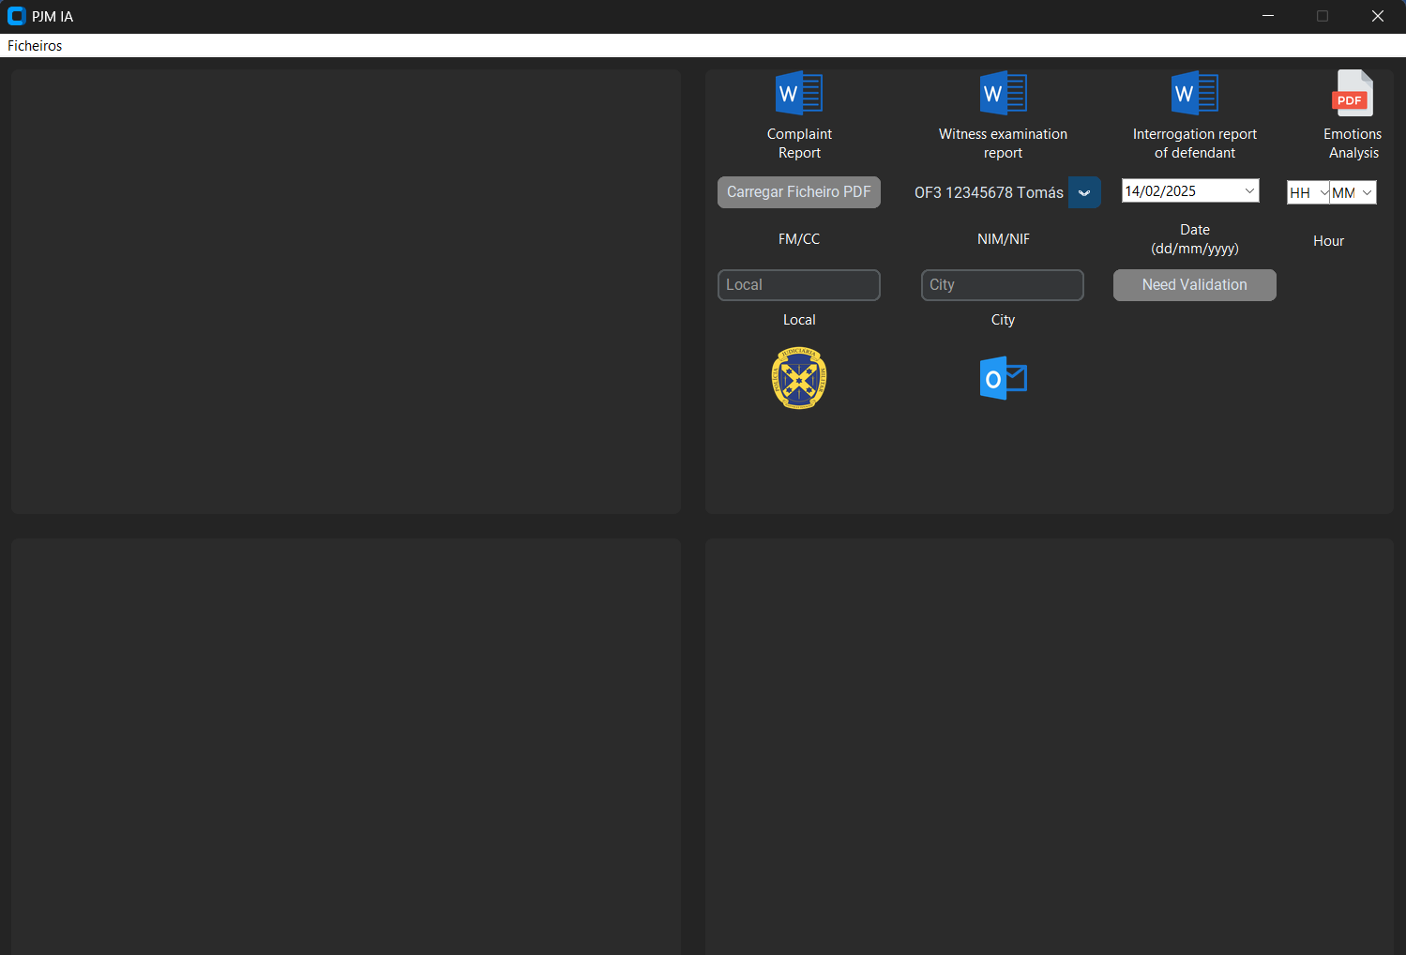

In the top-right corner, several options are available, including three Word documents:
- "Complaint Report"
- "Witness Examination Report"
- "Interrogation Report of Defendant"
These documents are officially used by the PJM (Polícia Judiciária Militar), each corresponding to a specific type of case.
A PDF document is also available, containing an initial section that includes details about the interviewee, interviewer, and interview location, along with an introductory summary of the session (limited to 1600 characters).
Within the same document:
- Annex A contains the full transcription of the interrogation.
- Subsequent annexes present the sentiment analysis results, structured in 10-second intervals, displaying the emotion classification for each analysed vector (FER, SER, and text sentiment analysis).
Additionally, on the second row of options, there is a button labeled "Load PDF File", designed to import the interviewee’s FM (Folha de Matrícula) or CC (Cartão de Cidadão). Once the information is successfully uploaded, the button will turn green, indicating completion.
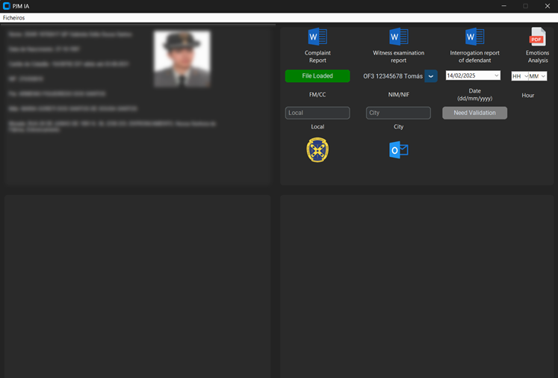
On the right side of the previously mentioned button, there is a combo box displaying the NIM (Número de Identificação Militar) and the name of the interrogators. Next to it, there is another combo box for selecting the interview date, which must be filled in according to the provided interview information.
Similarly, the time field is divided into two separate combo boxes, allowing the user to specify the hour and minutes of the interview.
The second-to-last row of menu options includes two text boxes:
- One for specifying the location of the interview.
- Another for the city where it took place.
If these fields are left blank, they will automatically assume the default values based on the system settings of the machine running the program.
On the same row, there is also an informational button that will display “Need Validation” if any of these fields remain unfilled. Once all fields are correctly entered, the button status will update to “Validated”.
Note: The previously mentioned fields are optional and do not prevent the program from proceeding with its analysis. If the data is not entered, the interviewer can manually complete the information later in the Word document.
The PJM icon serves as a shortcut to the PJM website, while the Outlook icon opens the machine’s Outlook application with the existing system account, automatically attaching the interrogation data for easy email forwarding.
In the top left corner, there is a dropdown menu containing the following options:
- Load Video
- Load Audio Recording
- Use Camera
- Exit, which closes the program, functioning the same way as the "X" button in the window.
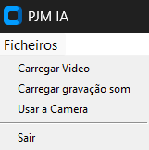
The "Load Video" option allows users to upload pre-recorded interrogation videos in the following formats: .mp4, .avi, and .mov. Selecting this option opens a file selection window where a compatible file must be chosen.
Similarly, the "Load Audio Recording" option enables the user to upload audio files in .mp3, .wav, and .ogg formats. The process is identical to loading a video.
The final option, "Use Camera", opens a live camera feed and starts recording in real time. To exit this mode, the user must press the "Q" key, which will stop the recording. Alternatively, the user can close the recording window by clicking the "X" button.
Lastly, as previously explained, the bottom left and right sections of the interface contain quantitative emotion analysis graphs. The left-side graph corresponds to Facial Emotion Recognition (FER), which logs an emotion count each time a change occurs. The right-side graph corresponds to Speech Emotion Recognition (SER), which analyzes the voice tone in 10-second intervals, recording and classifying the detected emotions.
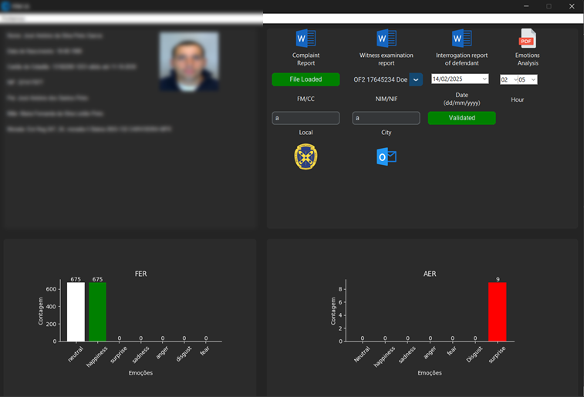
When the analysis process is complete, and both emotion analysis graphs are displayed, all documents will have been fully generated and can be opened for review.
At the end of the process, all temporary documents created during the analysis are deleted. Simultaneously, a new folder is automatically created inside the "Corpus" directory, named according to the interviewee's ID (Citizen Card number) and the date and time of the interview (e.g., 12345678_YYYY-MM-DD_HH-MM-SS).
Inside this folder, the following fully completed documents will be stored:
- The three standard reports used by the PJM:
  - "Complaint Report"
  - "Witness Examination Report"
  - "Interrogation Report of Defendant"
- The automatically filled PDF report, including all relevant case details.
- A processed video of the interview, in which emotion classifications are displayed in the bottom left corner at 10-second intervals, visually tracking the subject’s emotional state throughout the session.
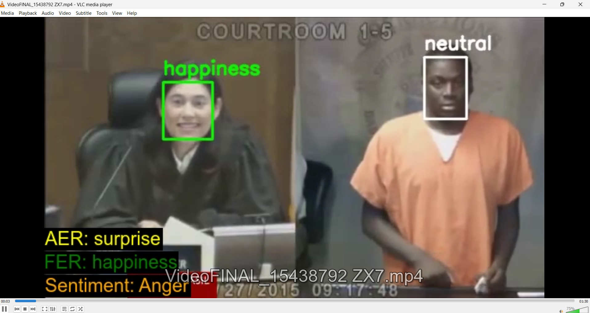

Instalation

For installation, the program consists of three files, and the user should run the file named PJM_IA_Installer.exe to initiate the installation process.
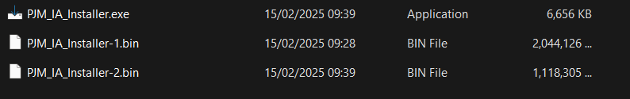
After double-clicking to start the installation, the initial installation window should appear. The user must then click the "Install" button to proceed with the installation.
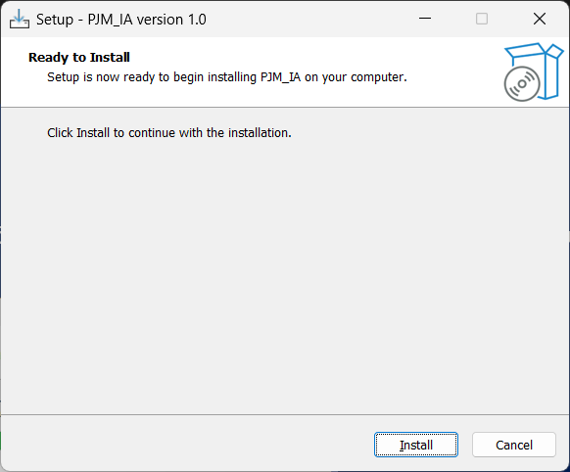
There is no need to select the installation directory, as the program is automatically installed in the system's program directory by default. The installation process may take some time, so users should allow it to complete fully without interruption.
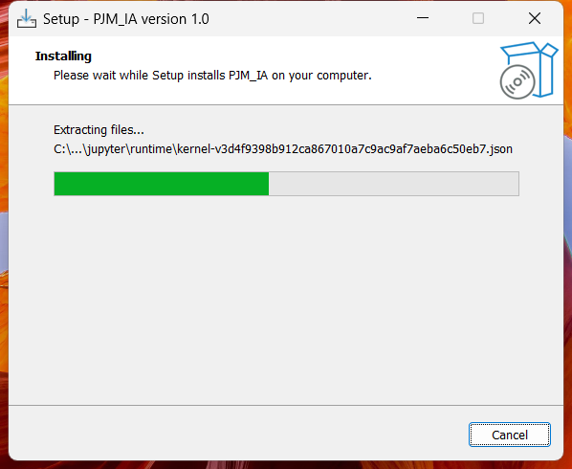
At the end of the installation, you may choose to run the program immediately or later. To launch it right away, simply select the checkbox next to "Run PJM_IA now" before clicking "Finish".
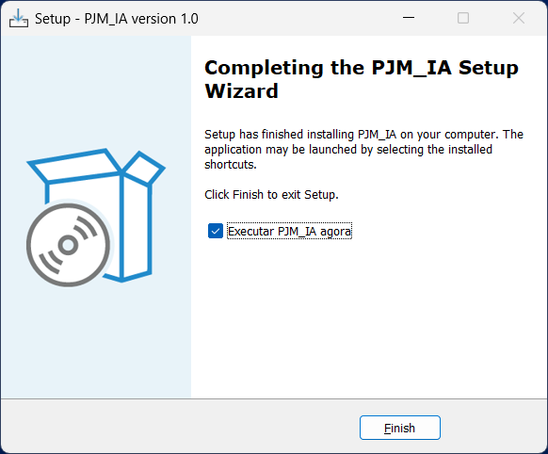
When executing the program, two windows will open:
- A command-line window, which must remain open throughout the entire process. If this window is closed, the PJM/IA program will also be terminated.
- The login window, where users must enter their credentials to access the system.
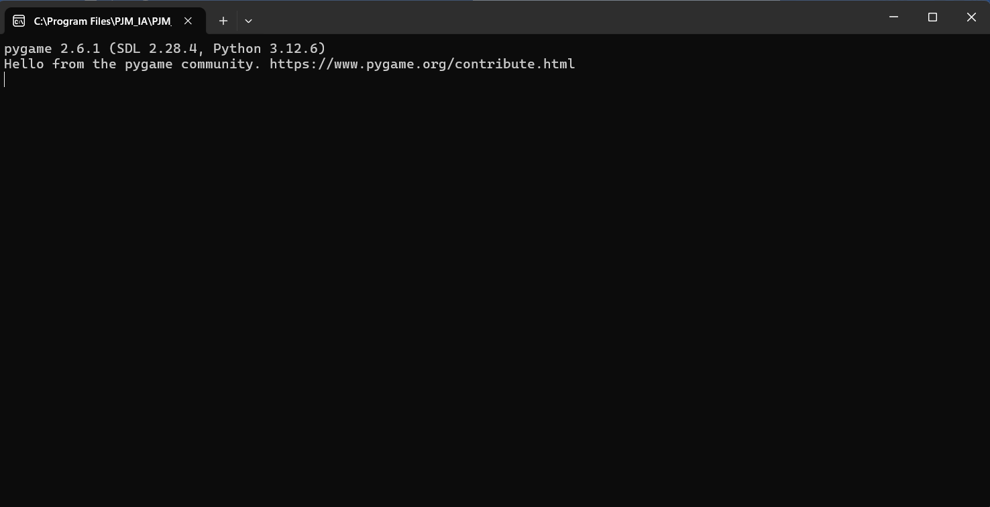
In addition to the installation directory, the program will also create a shortcut on the desktop for quick and easy access.
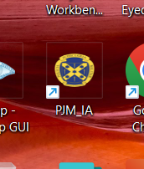

Usage Mode

The program starts with the authentication process, as mentioned in the Operation Module chapter. In the main menu, the first step is to load the information related to the interviewee. This step is mandatory, and failing to complete it will result in an error.
Upon loading the Military Registration Form (FM) or Citizen Card (CC), a menu will appear in the upper-left corner, displaying a summary of relevant information to assist the investigator in conducting the interrogation.
As a second step, which is optional, the investigator should enter their details in the combo boxes and text boxes located in the upper-right section of the program. If these fields are left blank, their values will default to "None", except for the Location and City fields, which will be automatically assigned based on the system's IP address.
Next, the user proceeds to the program's main functionalities. As previously mentioned, the system allows three types of input options: Loading Videos, Loading Audio Files, or Using the Camera for real-time recording.
- Input Video
In the upper-left corner, within the dropdown menu, the user should select the option "Load Video." This will open a file selection window where a video must be chosen in one of the supported formats: .mp4, .avi, or .mov. Once selected, a new window will open displaying the video analysis in progress.
The user should allow the video to play until they reach the desired stopping point for analysis. By default, the program will process the entire video unless manually interrupted.
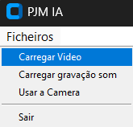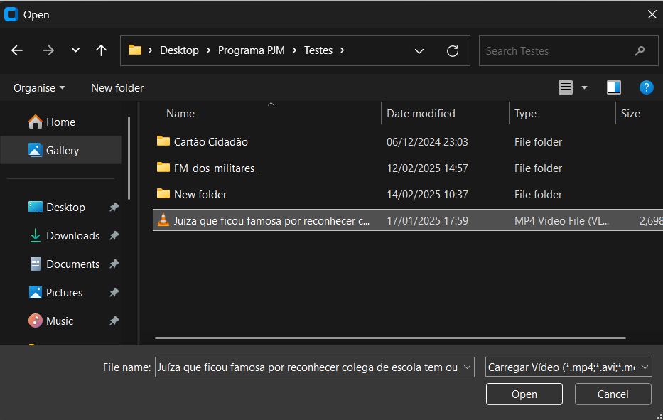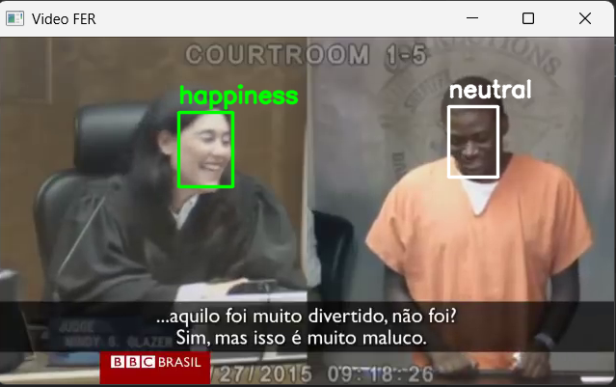
Once the previous process is completed, the FER graph (Facial Emotion Recognition) will appear in the lower-left corner. However, the program will continue processing the remaining data, and the analysis is not yet complete.
The process will only be finished once the SER graph (Speech Emotion Recognition) appears in the lower-right corner.
This analysis takes a few minutes, and the user should allow the process to run until the SER graph is displayed, indicating that the full emotional analysis has been successfully completed.
At this point, the documents available in the upper-right corner, namely the three Word documents and the PDF document, are ready and can be opened.
Simultaneously, at the end of the previous process, the program automatically creates a folder in the installation directory, specifically within the /Corpus folder. This folder is named according to the interviewee's identification number (CC) and the date and time of the interview (e.g., 12345678_AAAA-MM-DD_HH-MM-SS).
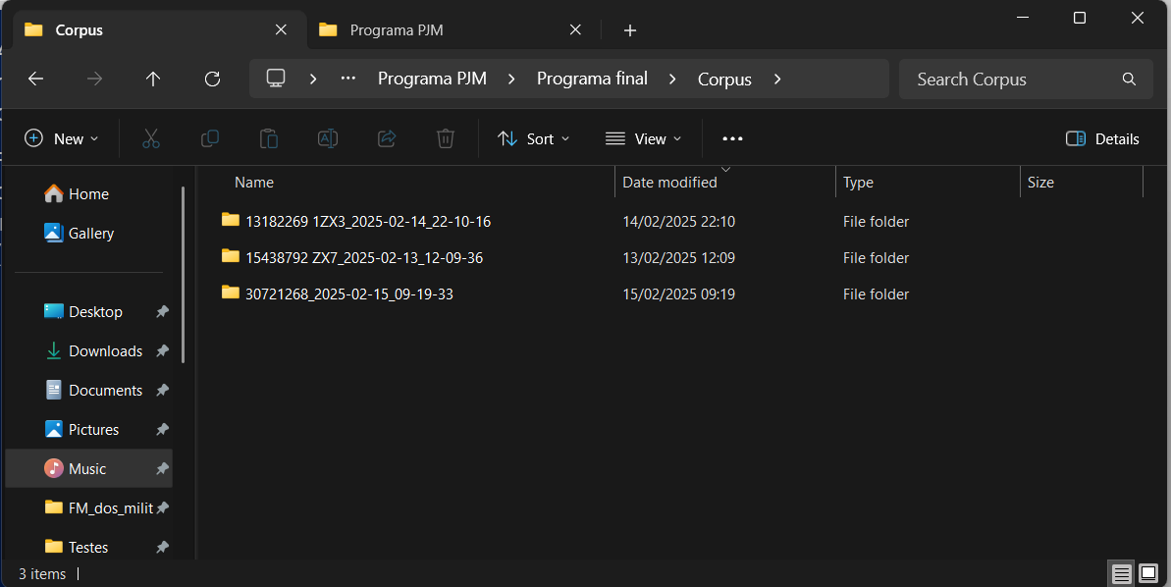
Inside the folder, we can find the three completed Word documents, as well as the PDF document and the processed video. The video includes annotations displaying the detected emotions from FER (Facial Emotion Recognition), SER (Speech Emotion Recognition), and Sentiment Analysis.
At this stage, the interrogator should delete any Word files that do not correspond to the interviewee, ensuring that only the relevant documents are retained.
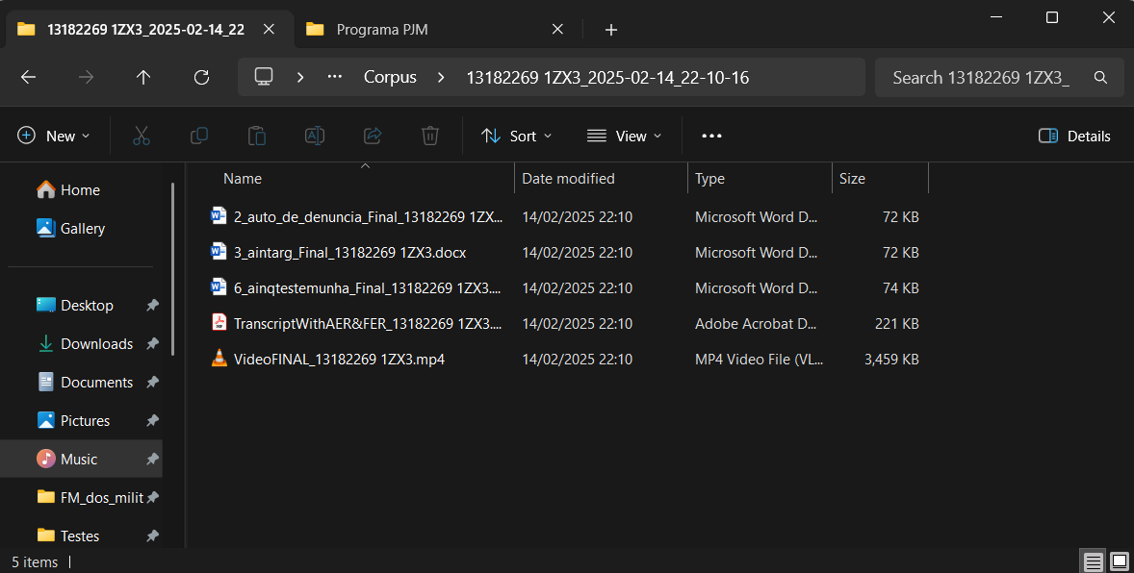
- Input audio
The procedure is identical to the previous one, with the key difference being that in this case, the program does not analyse FER (Facial Emotion Recognition). Instead, it only processes SER (Speech Emotion Recognition).
Apart from this distinction, the rest of the procedure remains exactly the same as before.
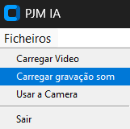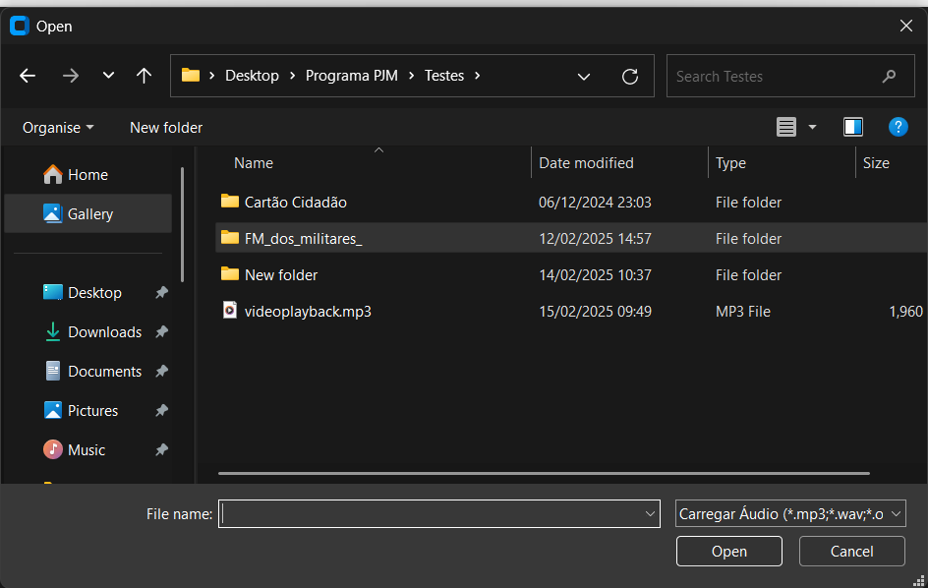
Unlike the previous process, no additional window will open; instead, the program will simply process the audio in the background. This processing time can be considerable, especially for larger audio files.
At the end of the process, a graph related exclusively to SER (Speech Emotion Recognition) will appear in the bottom left corner of the interface. At this point, the documents in the top right corner—namely the three Word documents and the PDF report—will be fully generated and ready to be opened.
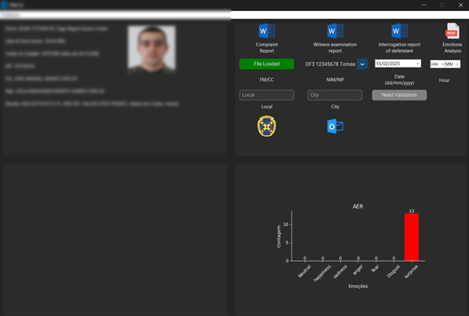
Simultaneously, at the end of the previous process, the program automatically creates a folder within the installation directory, specifically inside the /Corpus folder. The folder is named based on the interviewee's identification number (CC) along with the date and time of the interview (e.g., 12345678_AAAA-MM-DD_HH-MM-SS).
Inside the folder, you will find the three completed Word documents, as well as the PDF report and the audio file used for analysis. Additionally, if a video was processed, it will contain annotations displaying the detected emotions (SER and Sentiment Analysis). At this stage, the investigator must delete any Word files that do not correspond to the interviewee.

- Streaming
In the streaming or open camera mode, your machine must be equipped with a USB-connected camera as well as a USB-connected microphone. It is essential to comply with the technical requirements to ensure proper functionality.
To start the streaming mode, navigate to the cascading menu in the top-left corner and select "Use Camera". This will open a new window displaying the live camera feed.
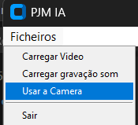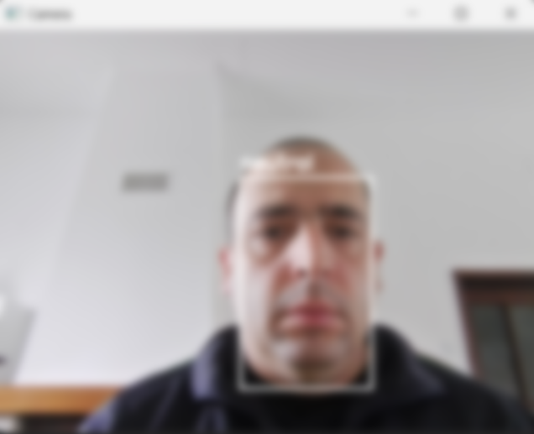
At the end of the recording, you should press the "Q" key. This action will stop and interrupt the recording, after which you should close the camera window manually.
From this point on, the process follows the same steps as loading a pre-recorded video, as explained in section 1. Initially, the FER graph will appear in the bottom-left corner, indicating that the facial emotion recognition process is complete. However, the program will continue processing the remaining data, and the analysis will only be fully completed when the SER graph appears in the bottom-right corner.
This processing phase may take several minutes, and it is important to allow it to run until the SER graph is fully generated.
From this moment, the documents available in the upper-right corner, namely the three Word documents and the PDF report, are ready to be opened.
Simultaneously, at the end of the process, the program creates a folder within the installation directory, specifically inside the /Corpus folder. This folder is named after the interviewee’s Citizen Card (CC) number, along with the date and time of the interview (e.g., 12345678_YYYY-MM-DD_HH-MM-SS).
Inside the folder, you will find the three completed Word documents, as well as the PDF report and the processed video. The video includes annotations displaying the detected emotions (FER, SER, and Sentiment Analysis).
At this stage, the interrogator should delete any Word documents that do not correspond to the interviewee.

For the streaming functionality, the program operates independently for all other features.
The same that 1.
The program follows a logic where all information is stored within the installation directory. Each time the program analyzes an interview, it creates a dedicated folder within the main directory to store all related data. Consequently, this will inherently require additional storage space.
For testing purposes, fictitious names were created. However, in the final version, the program will be classified as restricted and will include the correct information of the interrogators

